**1.  INTRODUCTION**

**1.1 ABOUT THE PROJECT**

This project report entitled **“SONY TV SHOWROOM MANAGEMENT SYSTEM”** using front-end gambas 3.0 and back-end mysql. A systematic approach made towards maintaining ‘purchase details, sales details, stock details, customer details, payment details, delivery details, service details’ details along with the generation of well-formatted reports.

This master module has of stock details, delivery details, purchase form deals with purchase order of TV item based on the stock. The level is increased when some purchase can be done and it can be monitored frequently by the stock.

The transaction module maintainly purchase details, sales details, customer details, payment details, delivery details, service details stock from deals with the details of the stock maintained in the stores.

Sales deals with sales order of TV item base on the stock level is increased when some sales can be done and it can be monitored us regular supplier or new supplier the sales details system can decrease the stock level when some sales.

The module has also maintains order process deals with the information about the supplier are different s regular supplier or new supplier the regular seller is provide by special offer discount. This helps to motivate some of new seller to become a regular seller.

**1.2 HARDWARE SPECIFICATION**

**Processor Name** : Pentium Dual Core

**Speed** : 2.664 GHz

**Main Memory** : 512 MB

**Cache Memory** : 1024 KB

**Hard Disk** : 80 GB

**Keyboard** : 110 Keys

**Mouse** : Optical Mouse

**Monitor** : 15’’ LCD Color Monitor

**1.3 SOFTWARE SPECIFICATION**

The configuration given below is the software handled for the system development.

**Front - End** : GAMBAS

**Back - End** : MySQL

**Operating System**  : LINUX ZORIN

**2. SYSTEM ANALYSIS**

**2.1 PROBLEM DEFINITION**

The project entitled **“Sony Tv Showroom Management System”** is developed to maintain a consistent transaction which links the fields of both product purchase stock and delivery of Sony tv the new system is designed to solve almost all problem faced by existing system. Reports were produced for the purchase details, product details, delivery details and customer details.

**2.2 SYSTEM STUDY**

The study of the system deals with needed to carry out preliminary investigation. The study proposal should be produced by the user Sony tv and the study can be performed only of the existing system. Since it give the structure and functioning of the system.

The methods used in the system analysis were interviews, observation and discussion. The existing system is manual one. But user found out some problem in the existing system. There is no provision for maintain the employees in the company. Moreover there is no provision for giving discount to agent while deliveries are made. Similarly there is no provision for giving commission while purchases are made.

## Drawbacks of the Existing System

* There is no provision for giving discount while purchase product and delivery issues.
* New users does not easily understand.
* Duplication of data does not avoided.
* There is chance for loss of record due to mishandling.
* There is possibility for error while updating details.
* The time required to process data and generate the reports is very high.
* Stock products not updated very well.
* Agent information’s does not maintained properly.

**2.3 PROPOSED SYSTEM**

The basic for the proposed system is the recognition of the need for improving the existing system or procedure. The proposed system aims at overcoming the drawbacks of the existing system. The proposed system is coded and designed using the visual basic concept. The concept of visual basic helps in providing the better security and faster access to data stored in the database, of the proposed system.

Thus the proposed system maintains a huge database, which records all the details pertaining to agents and also keeps track of all the details which are necessary for the organization. The basis of the system lies in capturing and analyzing the information at various levels and effective decision making.

**Advantages of the Proposed System**

* Completely menu-driven and user-friendly.
* New users easily understand.
* Avoids the duplication of records.
* Provides faster and efficient information processing.
* Supports efficient data management.
* Highly flexible.
* Valid and secure.
* Provides timely information.
* Add the new facility type of discount for both the purchase and sales amount.
* Also stock updated for every transaction process.

**SYSTEM DESIGN**

**3.1 FILE SPECIFICATION**

**Table Name :** employerlogin_form

**Purpose :** This table is used for administrator to login to this system

|  |  |  |  |  |
| --- | --- | --- | --- | --- |
| **FIELD NAME** | **DATA TYPE** | **SIZE** | **CONSTRAINTS** | **DESCRIPTION** |
| Username | Varchar | 25 | Not null | User name |
| Password | Varchar | 25 | Not null | Password |

**Table Name :** employeelogin_form

**Purpose :** This table is used for administrator to login to this system

|  |  |  |  |  |
| --- | --- | --- | --- | --- |
| **FIELD NAME** | **DATA TYPE** | **SIZE** | **CONSTRAINTS** | **DESCRIPTION** |
| Empname | Varchar | 25 | Not null | Emp name |
| Empid | Varchar | 25 | Not null | Emp id |
| Password | Varchar | 25 | Not null | Password |

**Table Name :** registration_form

**Purpose :** This table is used for registration of this system

|  |  |  |  |  |
| --- | --- | --- | --- | --- |
| **FIELD NAME** | **DATA TYPE** | **SIZE** | **CONSTRAINTS** | **DESCRIPTION** |
| Empname | Varchar | 25 | Not null | EmpName |
| Empid | Varchar | 25 | Not null | Employid |
| Dob | Varchar | 25 | Not null | Dob |
| Gender | Varchar | 25 | Not null | Gender |
| Age | Varchar | 25 | Not null | Age |
| Qualification | Varchar | 25 | Not null | Qualification |
| Phoneno | Varchar | 25 | Not null | Phoneno |
| Address | Varchar | 25 | Not null | Address |
| City | Varchar | 25 | Not null | City |

**Table Name :** purchase_details

**Purpose :** This table is used to store purchases details

|  |  |  |  |  |
| --- | --- | --- | --- | --- |
| **FIELD NAME** | **DATA TYPE** | **SIZE** | **CONSTRAINTS** | **DESCRIPTION** |
| Productmodel | Number | 10 | Primary key | Product model |
| Productname | Varchar | 25 | Not null | Product name |
| Amount | Number | 15 | Not null | Amount |
| Quantity | Number | 10 | Not null | Quantity |
| Purchasedate | Varchar | 25 | Not null | Purchase date |
| Tax | Number | 10 | Not null | Tax |
| Totalamount | Number | 10 | Not null | Total amount |

**Table Name :** sales_details

**Purpose :** This table is used to store sales details

|  |  |  |  |  |
| --- | --- | --- | --- | --- |
| **FIELD NAME** | **DATA TYPE** | **SIZE** | **CONSTRAINTS** | **DESCRIPTION** |
| Productmodel | Number | 10 | Primary key | Product model |
| Productname | Varchar | 15 | Not null | Product name |
| Amount | Number | 10 | Not null | Number |
| Salesdate | Varchar | 15 | Not null | Sales date |
| Customername | Varchar | 30 | Not null | Customer name |
| Totalamount | Number | 10 | Not null | Total amount |

**Table name :** purchasereturn_details

**Purpose :**This table is used to store purchases return details

|  |  |  |  |  |
| --- | --- | --- | --- | --- |
| **FIELD NAME** | **DATA TYPE** | **SIZE** | **CONSTRAINTS** | **DESCRIPTION** |
| Productmodel | Number | 10 | Primary key | Product model |
| Productname | Varchar2 | 15 | Not null | Product name |
| Amount | Number | 10 | Not null | Number |
| Purchasedate | Varchar2 | 25 | Not null | Purchase date |
| Purchaseretdate | Varchar2 | 25 | Not null | Purchaseret date |
| Customername | Varchar2 | 30 | Not null | Customer name |
| Totalamount | Number | 10 | Not null | Total amount |

**Table name :** salesreturn_details

**Purpose :**This table is used to store purchases return details

|  |  |  |  |  |
| --- | --- | --- | --- | --- |
| **FILED NAME** | **DATA TYPE** | **SIZE** | **CONSTRAINTS** | **DESCRIPTION** |
| Productmodel | Number | 10 | Primary key | Product model |
| Productname | Varchar | 15 | Not null | Product name |
| Customername | Varchar | 25 | Not null | Customer name |
| Amount | Number | 10 | Not null | Amount |
| Quantity | Varchar | 10 | Not null | Quantity |
| Purchasedate | Varchar | 10 | Not null | Purchase date |
| Salesdate | Varchar | 10 | Not null | Sales date |
| Totalamount | Number | 10 | Npt null | Total amount |

**Table name :** stock_details

**Purpose :** This table is used to store stock details

|  |  |  |  |  |
| --- | --- | --- | --- | --- |
| **FILED NAME** | **DATA TYPE** | **SIZE** | **CONSTRAINTS** | **DESCRIPTION** |
| Productmodel | Number | 10 | Primary key | Product model |
| Productname | Varchar | 15 | Not null | Product name |
| Purchaseretdate | Varchar | 25 | Not null | Purchaseret date |
| Totalstock | Varchar | 10 | Not null | Total stock |
| Totalamount | Varchar | 10 | Not null | Total amount |

**Table name :** payment_details

**Purpose :** This table is used to store payment details

|  |  |  |  |  |
| --- | --- | --- | --- | --- |
| **FIELD NAME** | **DATA TYPE** | **SIZE** | **CONSTRAINTS** | **DESCRIPTION** |
| Productmodel | Number | 5 | Primary key | Product model |
| Customername | Varchar | 10 | Not null | Customer name |
| Date | Varchar | 15 | Not null | Date |
| Invoiceno | Varchar | 20 | Not null | Invoice no |
| Amount | Varchar | 25 | Not null | Amount |
| Tax | Varchar | 15 | Not null | Tax |
| Discount | Varchar | 20 | Not null | Discount |
| Totalamount | Varchar | 25 | Not null | Total amount |

**Table Name :** delivery_details

**Purpose :** This table is used to store delivery details

|  |  |  |  |  |
| --- | --- | --- | --- | --- |
| **FIELD NAME** | **DATA TYPE** | **SIZE** | **CONSTRAINTS** | **DESCRIPTON** |
| Productmodel | Number | 10 | Primary key | Product model |
| Salesperson | Varchar | 15 | Not null | Sales person |
| Date | Varchar | 18 | Not null | date |
| Customername | Varchar | 10 | Not null | Customer name |
| Invoiceno | Number | 10 | Not null | Invoice number |
| Productweight | Varchar | 10 | Not null | Product weight |
| Purchasedate | Varchar | 15 | Not null | Purchase date |
| Contactno | Varchar | 18 | Not null | Contact number |
| Streetaddress | Varchar | 10 | Not null | Street address |
| City | Varchar | 10 | Not null | City |

**Table Name :** service_details

**Purpose :** This table is used to store service details

|  |  |  |  |  |
| --- | --- | --- | --- | --- |
| **FIELD NAME** | **DATA TYPE** | **SIZE** | **CONSTRAINTS** | **DESCRIPTION** |
| Productmodel | Number | 10 | Primary key | Product model |
| Productname | Varchar | 15 | Not null | Product name |
| Quantity | Varcar | 18 | Not null | Quantity |
| Customername | Varchar | 25 | Not null | Customer name |
| Purchasedate | Varchar | 15 | Not null | Purchase date |
| Invoiceno | Varchar | 18 | Not null | Invoice number |
| Serviceamount | Varchar | 10 | Not null | Service amount |
| Servicedate | Varchar | 10 | Not null | Service date |

**3.3 MODULE SEPCIFICATION**

The modules are described below

* Master module
* Transaction module
* Report module

**MASTER MODULE**

The master module contains the follwing sub modules

* Stock details
* Service details
* Customer details
* Supplier details

**STOCK DETAILS**

This module is used to maintain the details about the stock such as product name, product model, purchase return date, total stock, total amount, quantity

**SERVICE DETAILS**

This module is used to maintain the details about the service such as product name, product model, quantity, customer name, purchase date, invoice no, service amount, service date

**CUSTOMER DETAILS**

This module is used to maintain the details about the customer such as first name, sure name, address, city, post code, product name, purchase date, address, contact number

**SUPPLIER DETAILS**

This module is used to maintain the details about the Supplier such as supplier name, supplier id, age, gender, phone number, address

**TRANSACTION MODULE**

The transaction module contains the following sub modules

* Purchase
* Purchase return
* Sales
* Sales return
* Payment
* Delivery

**PURCHASE**

The purchased items are maintained in this module. The goods are purchased from the supplier will be added to stock.

**PURCHASE RETURN**

The goods are returning to supplier, and the stock is reduced by purchase return details.

**SALES**

This is used to store the furniture goods. The furniture goods is sold them the stock is less and then added.

**REPORT:**

The report module contain the following sub modules

* Purchase report
* Purchase return report
* Sales report
* Stock report
* Payment report
* Delivery report

**PURCHASE REPORT**

The purchase report is used for providing the information about purchase item details.

**PURCHASE RETURN REPORT**

The purchase return report is used for providing the information about purchase return details.

**SALES REPORT**

This sales report is used for providing the information about sales item details

**STOCK REPORT**

This stock report is used for providing the information about stock item detail

**4. TESTING AND IMPLEMENTATION**

**TESTING**

Testing is an important phase of encounters in any developed product or frame work is the testing phase. It is because the developed product should be free from errors and it should be validated for accuracy. The product should work under manual conditions as long as the user gives proper input and therefore it should be checked for it robustness and should with stand and inform the users about the erroneous input.

To make the complete system the following level of testing has been adapted. These are:

* + Unit testing,
  + Modular testing,
  + Validation testing,
  + Verification testing,
  + Black-box testing.
  + Integration testing.

**UNIT TESTING**

Unit testing has been under taken as part of white box testing. With the classes of boundary value testing, control value testing and loop testing. In the testing the analyst tests the programs making up the system. Unit testing checks for syntax and logic error.

**MODULAR TESTING**

In modular testing each and every module is separately tested for various inputs. Values and the validity of the testing are checked with appropriate inputs are also given to detect the response of the software.

In the above testes, the software responded manner and number of error occurred. The software can be easily implemented in real time. The software user-friendly, as the tested in real time environment the occurrence of error is minimize

**VERIFICATION TESTING**

The purpose of the requirement phase is to ensure the user needs are properly understood before translating into design. Requirements are difficult to develop because it is hard to distinguish needs from wants.

**VALIDATION TESTING**

Validation is achieved though series of testing that demonstrate conformity with requirements. Both the plan and the procedures are designed to ensure that all the functional requirements are satisfied.

* All behavioral characteristics are achieved,
* All performance requirements are obtained.

**BLACK-BOX TESTING**

Approach to testing where the tests are derived from the program or component specification. The system is a black-box whose behaviour only be determined by studying its inputs and the related outputs. Another name for this is functional testing because the tester is only concerned with the functionality and not the implementation of the software.

**INTEGRATION TESTING**

Integrated testing is combining all the modules together and tests the system as a whole. All the modules that undergone unit testing are integrated together to get the whole software as a single module. This integration testing is a format procedure that must be executed carefully according to the need.

**IMPLEMENTATION**

Implementation means converting a new system or revised system into an operational one. Conversion is main aspect of implementation. It is the process of designing from the old system to the new one. Several procedures and documents are carried during conversion phase. Implementation of a modified application to replace an existing one. Using the same computer this type of conversion is relatively easy to handle provided there are no major changes in the file. The system has been tested with sample data changes are made to the user requirements and run in parallel with existing system during the training period.

The implementation training for the system user, how to work with this software should be given. The development of operating procedure to repair and enhance the system should be done. The installation new computers with required hardware and software specification are to be performed, if the present system is working manually.

Implementation included all those activities that take place to convert from the old system to the new one. The new system may be totally new replacing an existing manual or automated system or it may be a major modification for an existing syst

1. **CONCLUSION AND SUGGESTIONS**

**CONCLUSION**

The atomization system has been developed to satisfy the needs of the user for effectiveness and better quality of service. The Sony TV showroom management system meets all the system objectives and trail run has given a good result. The procedure for processing is simple. Sufficed numbers of reports have been provided according to the needs of the management. The entire system is window based and highly interactive, it is high degree of accuracy and user-friendliness.

Computerization of the system helps Sony TV showroom management in many ways. The Oil store management system can work comparatively faster than the manual system and also will be more reliable, generally human are prove to error. There may be error in critical works, but computer is involved, error free information is generated.

**SUGGESTIONS**

The system makes the possibilities smoothen to the Sony TV showroom management and this software with volumes of input/output data of all possible validation and results have been produce to be excellent. The dosing of this package can be extended to increase the facilities of old system.

Any changes that are likely cause system are presented with security measures. The system is very flexible so the maintenance and future enhancements based on changing environment and requirements are can be incorporate easily.

Additional reports can be added with the system to show the growth of the particular field for the whole trust. Thus even after the development phase, design and development of new application and their integration with the existing can be carried out with least effort.

**APPENDIX**

**APPENDIX-A (INPUT SCREENS)**

**A1.WELCOME FORM**

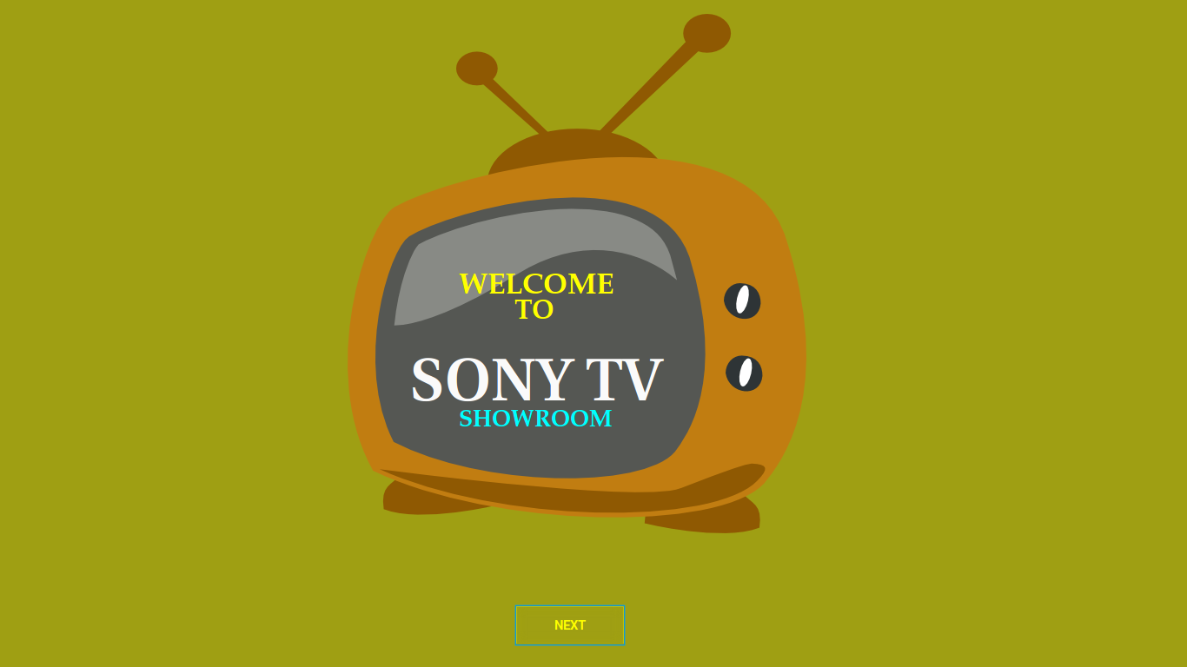

**A2. LOGIN FORM**

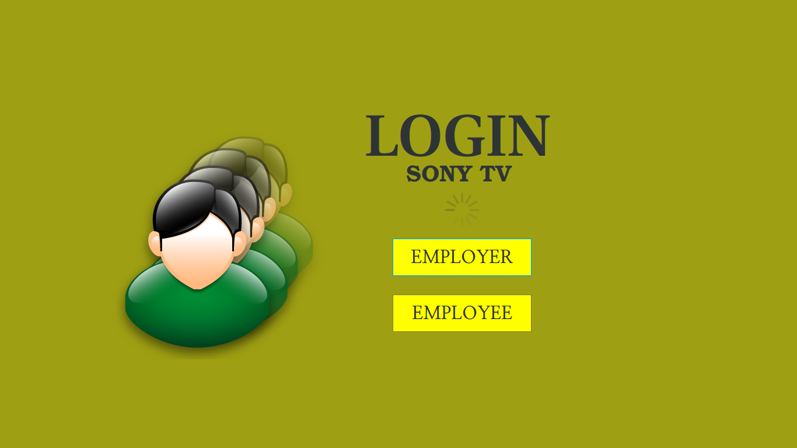

**A3. EMPLOYER LOGIN FORM**

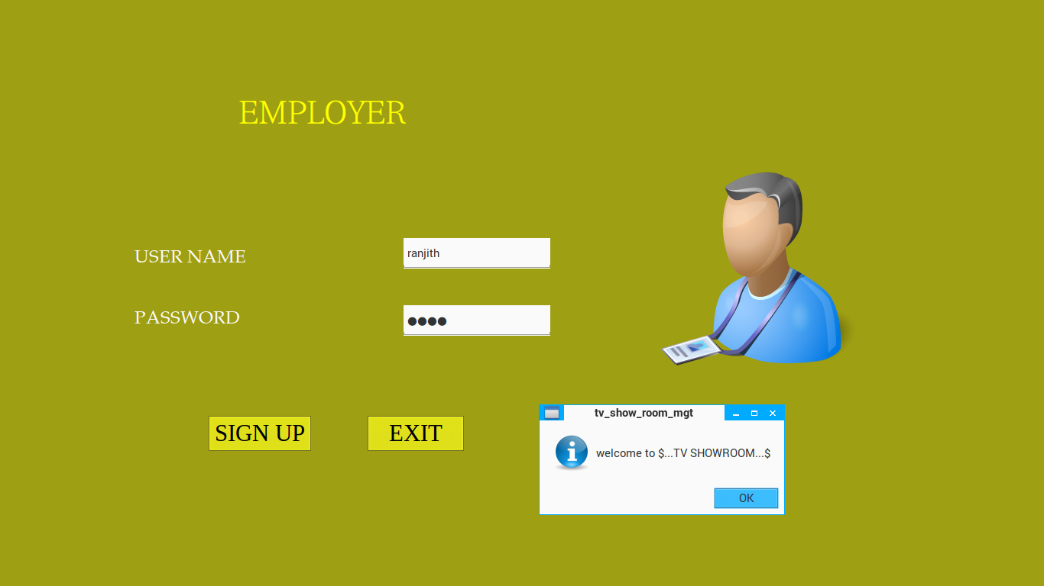

**A4. EMPLOYEE LOGIN FORM**

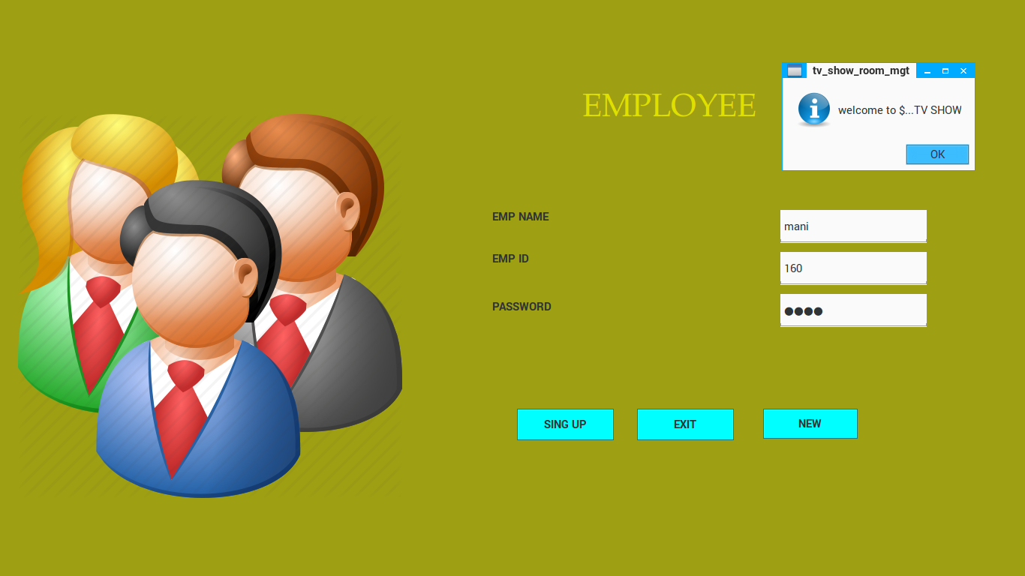

**A5. EMPLOYEE REGISTRATION DETAILS**

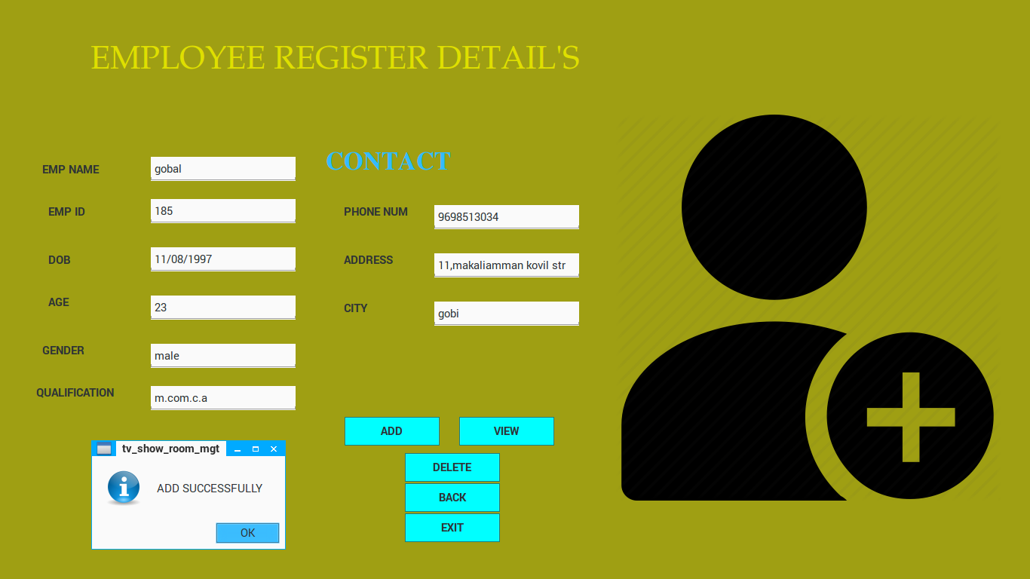

**A6. MDI DETAILS**



**A7. PURCHASE DETAILS**

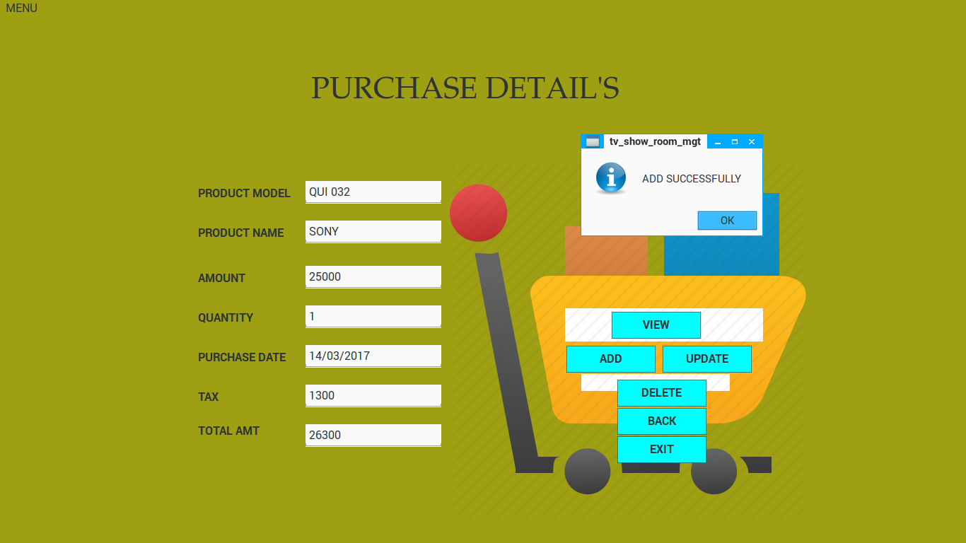

**A8.SALES DETAILS**

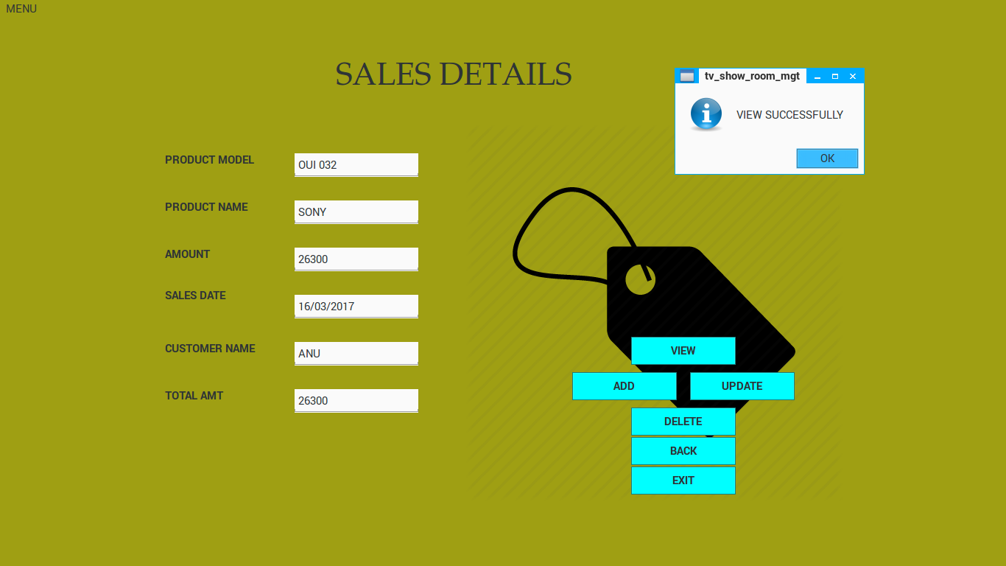

**A9. CUSTOMER DETAILS**

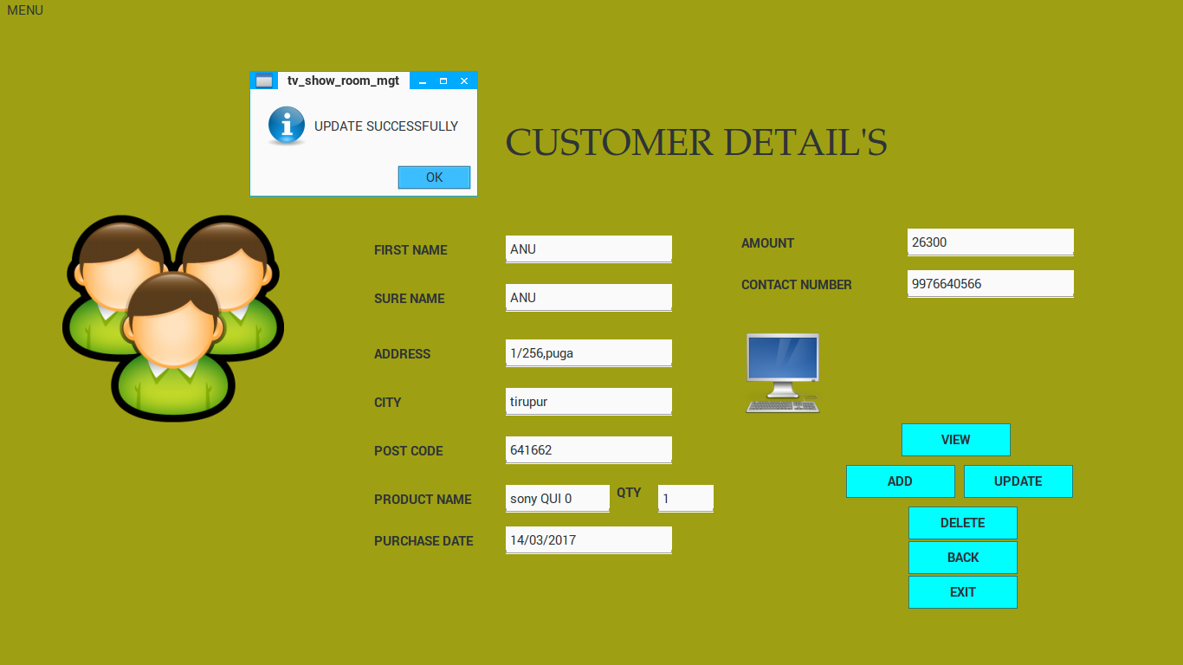

**A10. PAYMENT DETAILS**

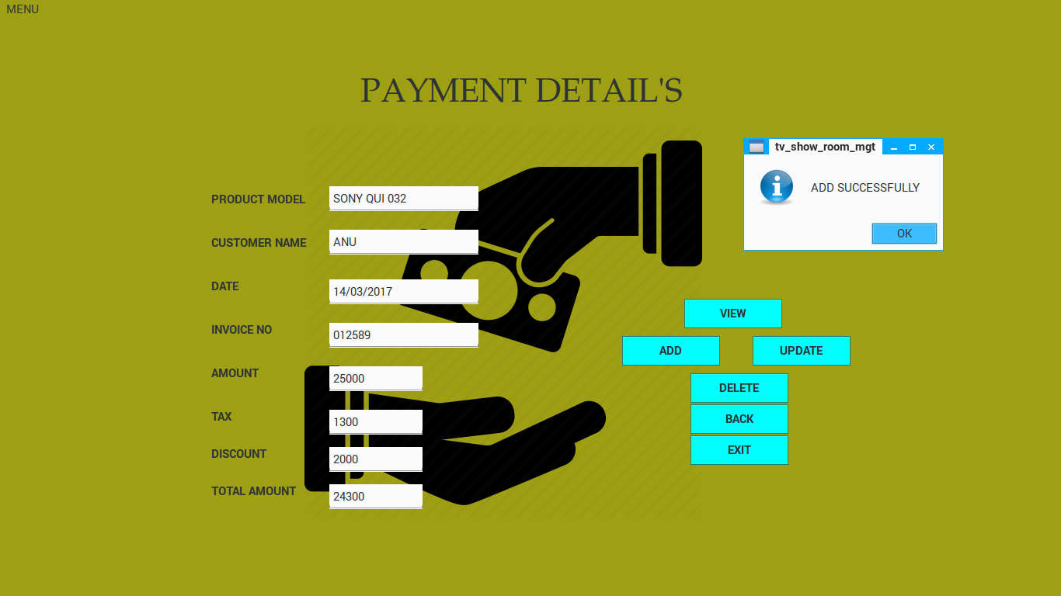

**A11. PURCHASE RETURN DETAILS**

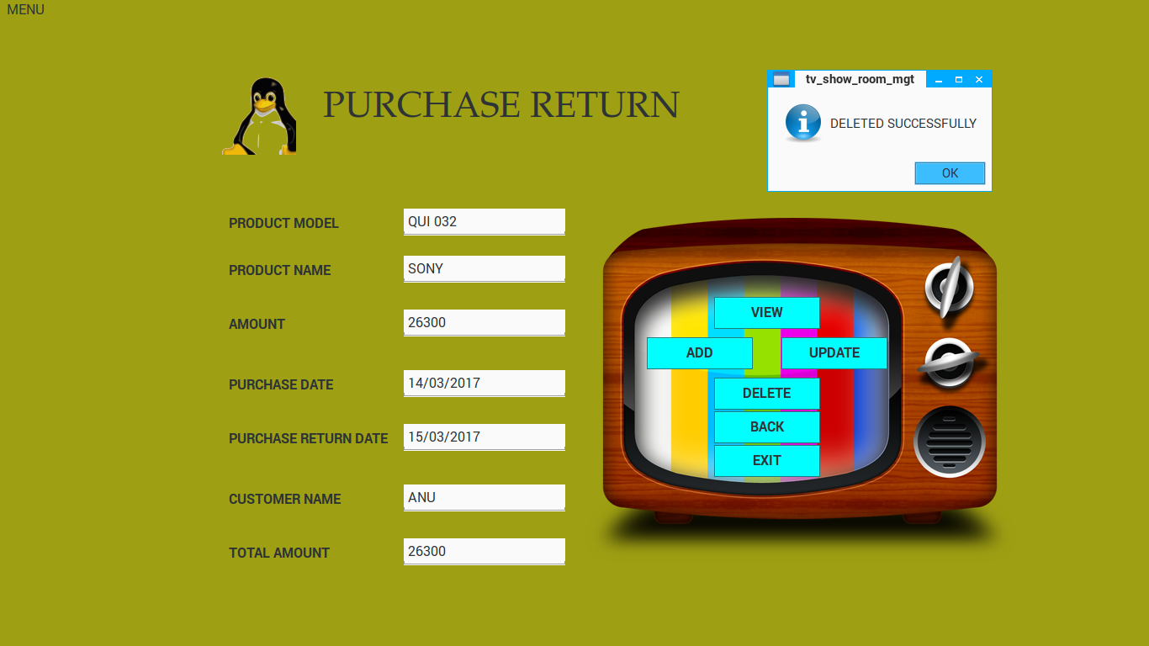

**A12. SALES RETURN DETAILS**

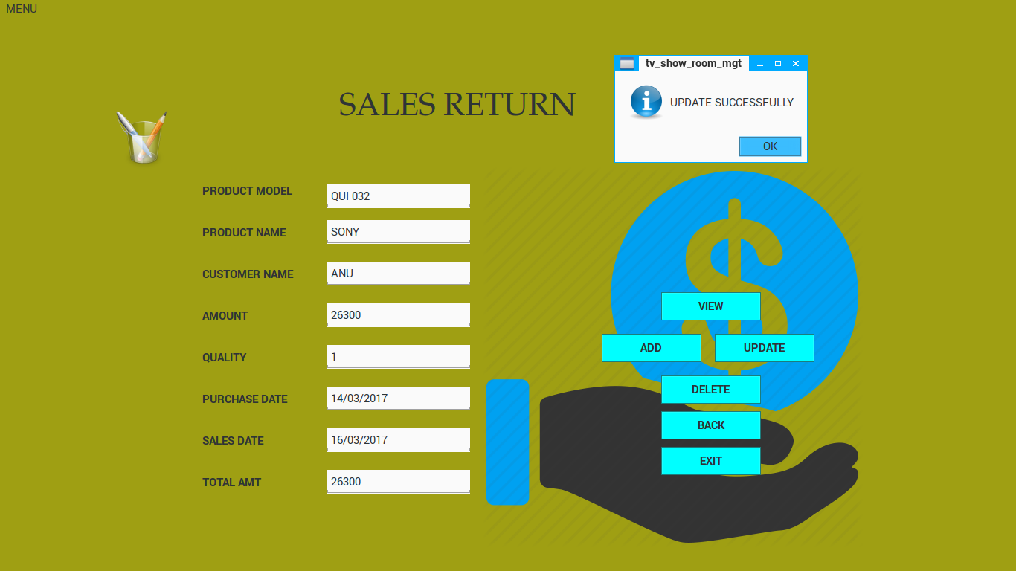

**A13. STOCK DETAILS**

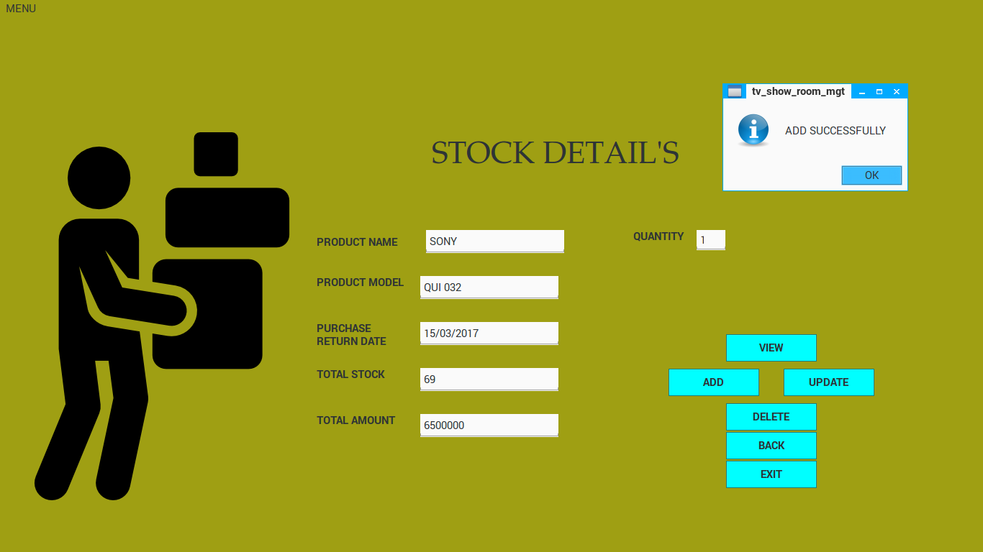

**A14. DELIVERY DETAILS**

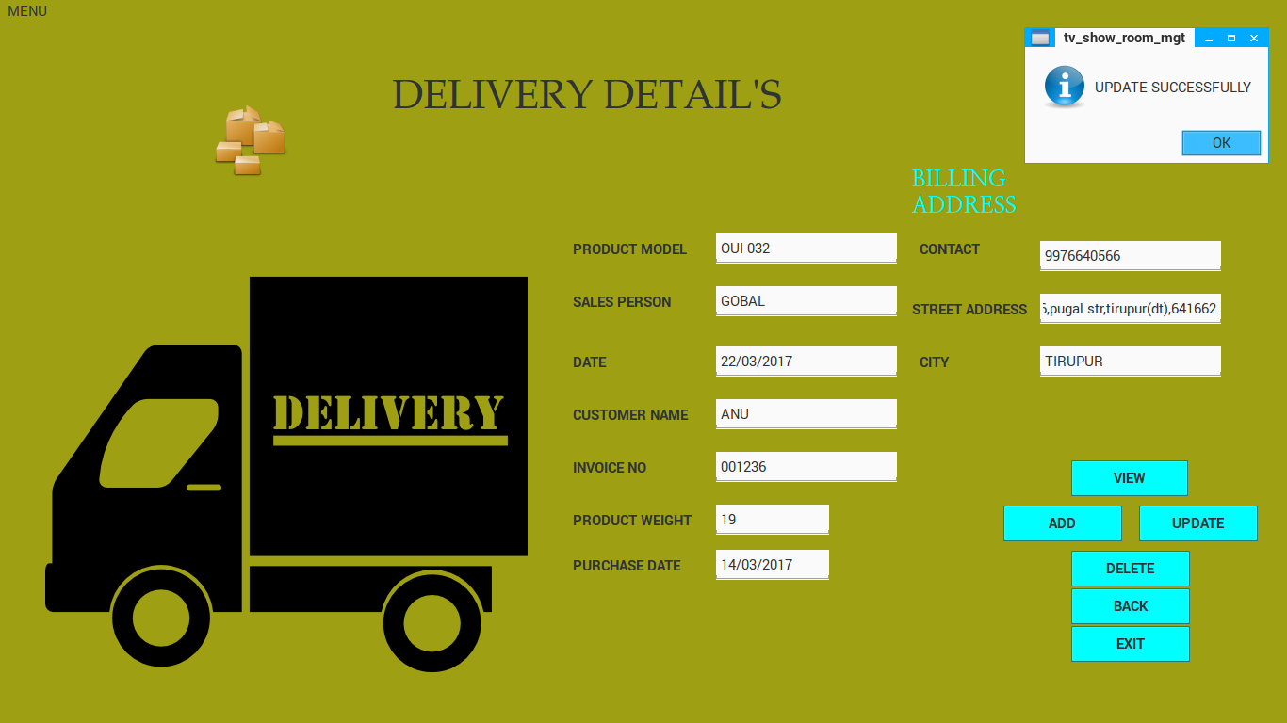

**A15. SUPPLIER DETAILS**

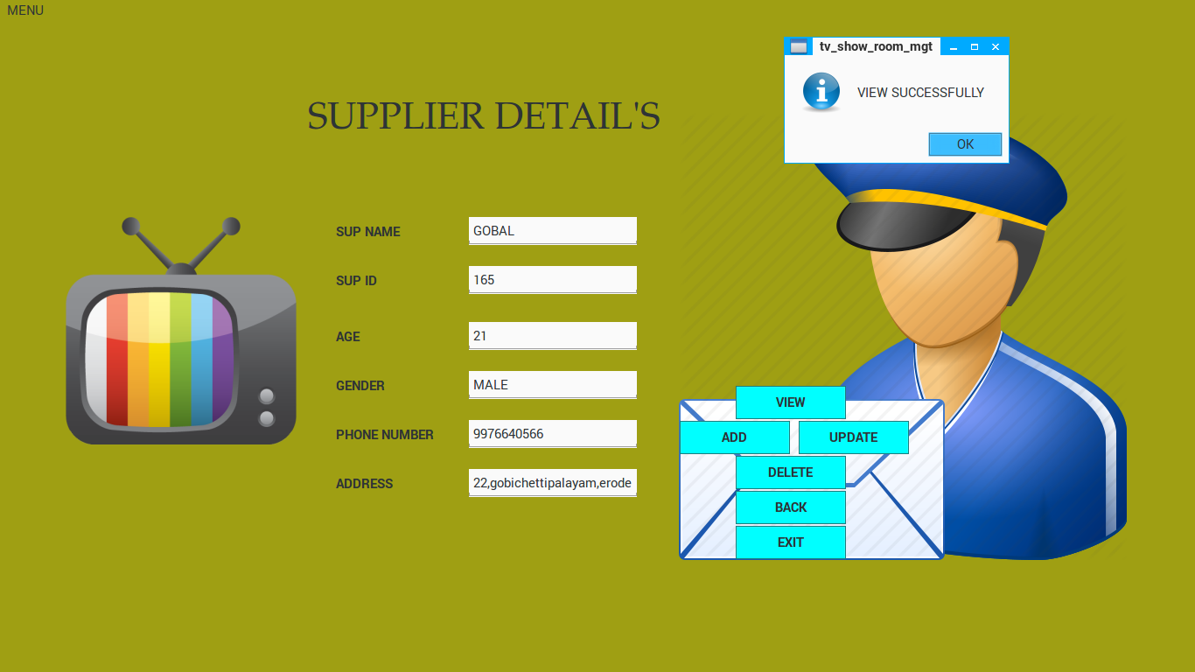

**A16. SERVICE DETAILS**

